No Ring Macrame Plant Hanger DIY
You can only make so many plant hangers using rings before you get bored. Check out this no ring macrame plant hanger DIY and get inspired to ditch the rings and be creative with your next plant hanger.
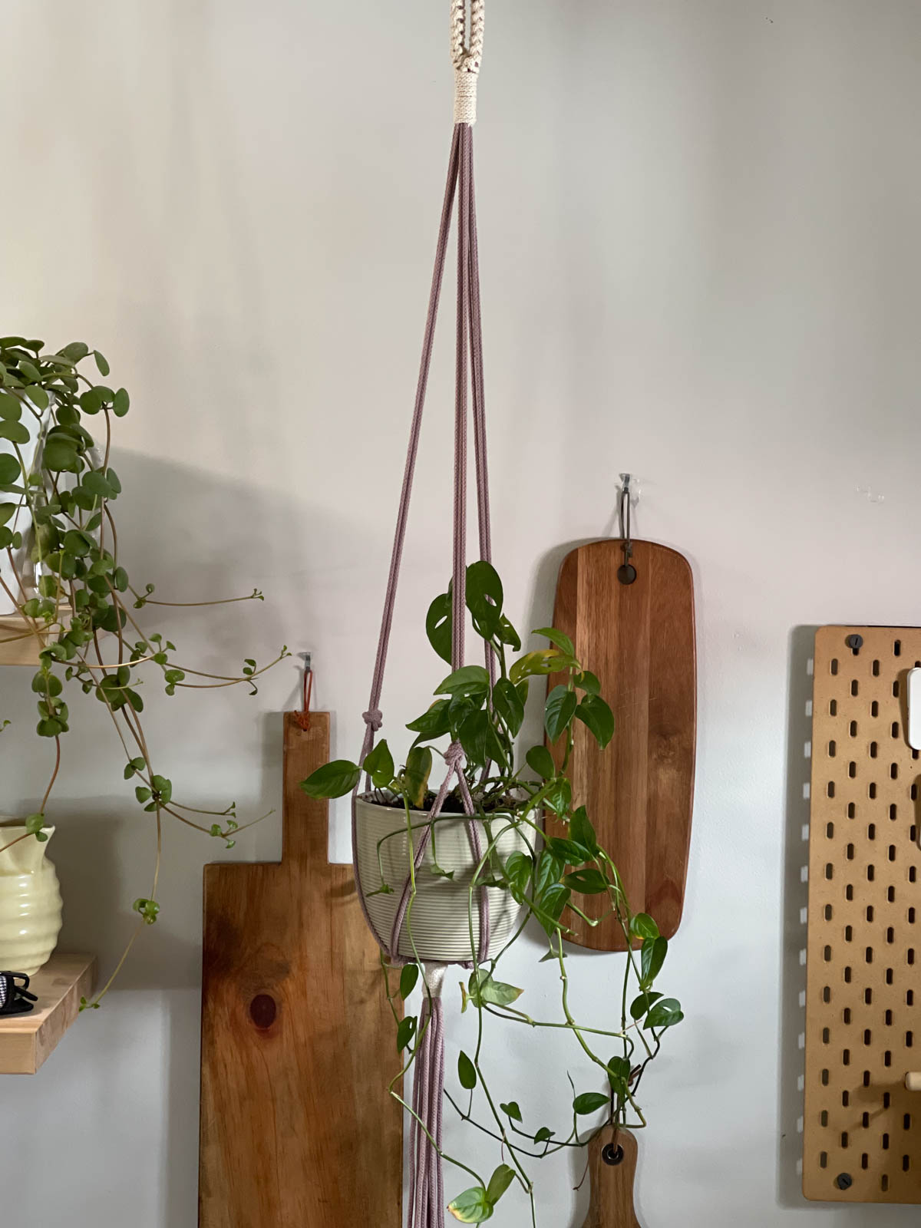
How to Make a No Ring Macrame Plant Hanger
There are all types of ways you can start a plant hanger without a ring and you can customize yours just the way you want.
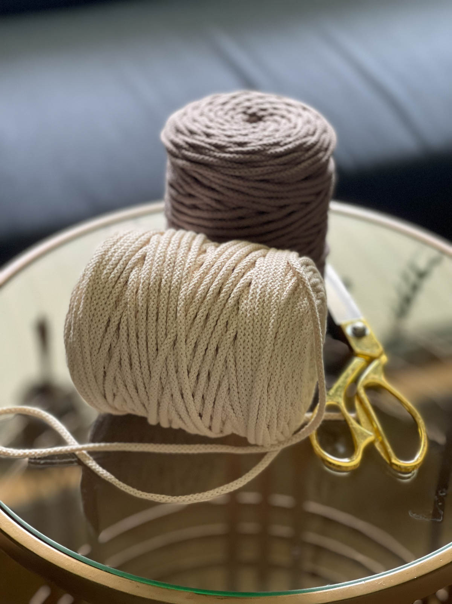
Supplies needed
- 4mm braided cotton string in the colors of your choice ( I used these, not an affiliate link I just love their products!)
I am really loving this string for plant hangers! It has a bit of stretch to it and it’s nice and strong, you can fringe it out, but I haven’t tried that yet. It’s definitely more modern than boho.
Step-by-step-tutorial
Step 1. Cut your strings
You will need six strings cut to 8ft in your main color choice. These strings will make the plant hanger. You also need one string cut to 8ft that you will use to accent the hanging loop and a 12 inch piece to make the gathering knot. Depending on how you decide to finish it you may need two 12 inch pieces.
Step 2. Create your hanging loop
Fold your six strings in half so that you have the center point. You can mark the center using a piece of tape.
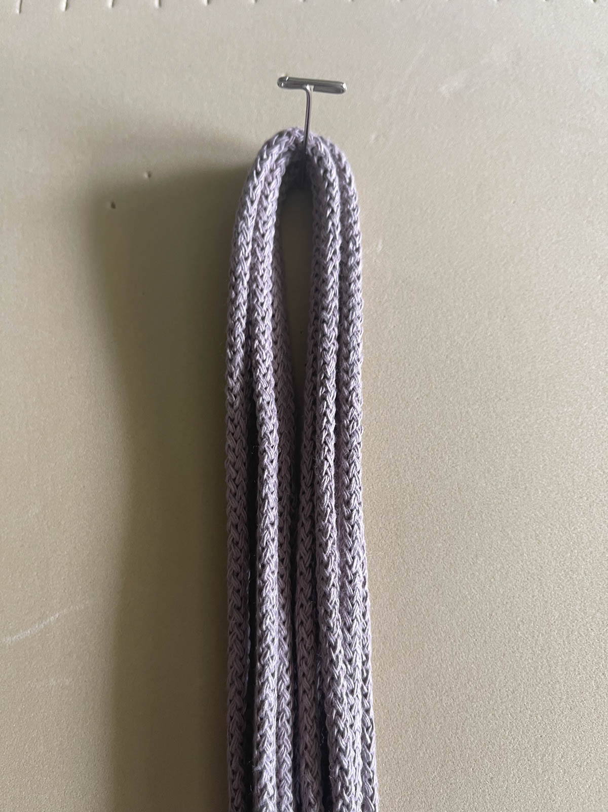
My loop is going to be six inches long, but you can make it as long as you want. When folded over it is three inches long which is plenty long enough for a hanging loop.
Take your accent string and make square knots around the main strings for your plant hanger. Think of those six strings as your filler cords and the accent string is the working cord.
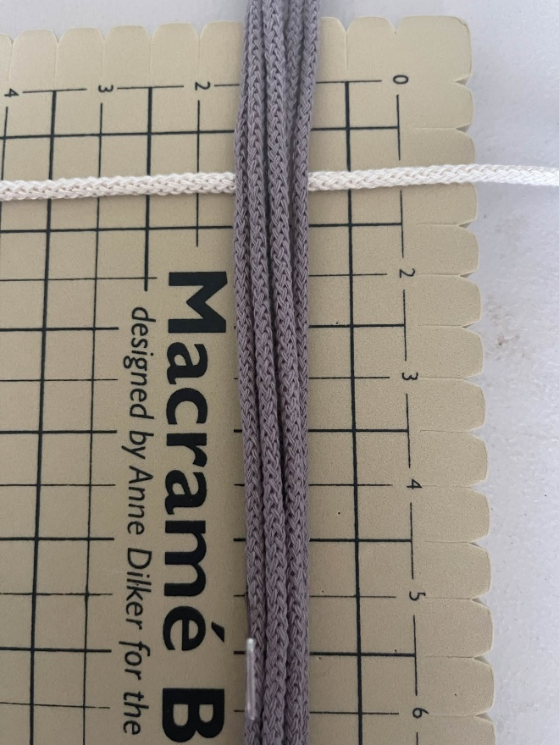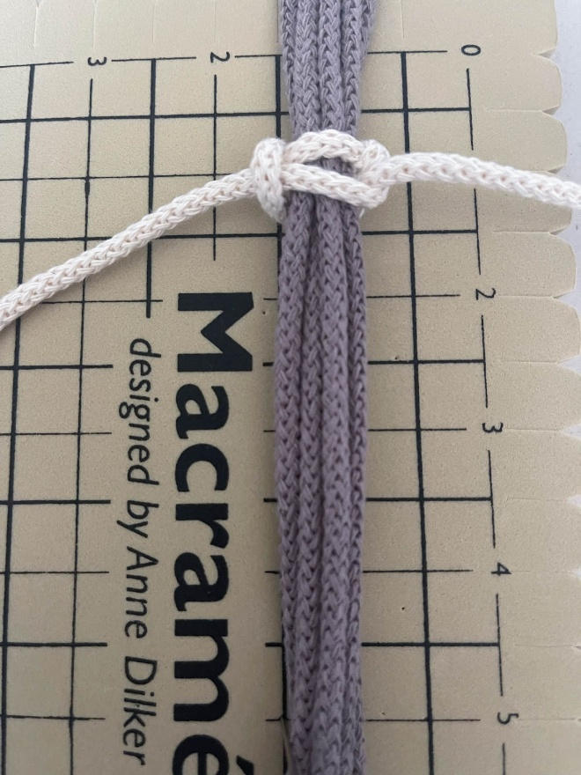
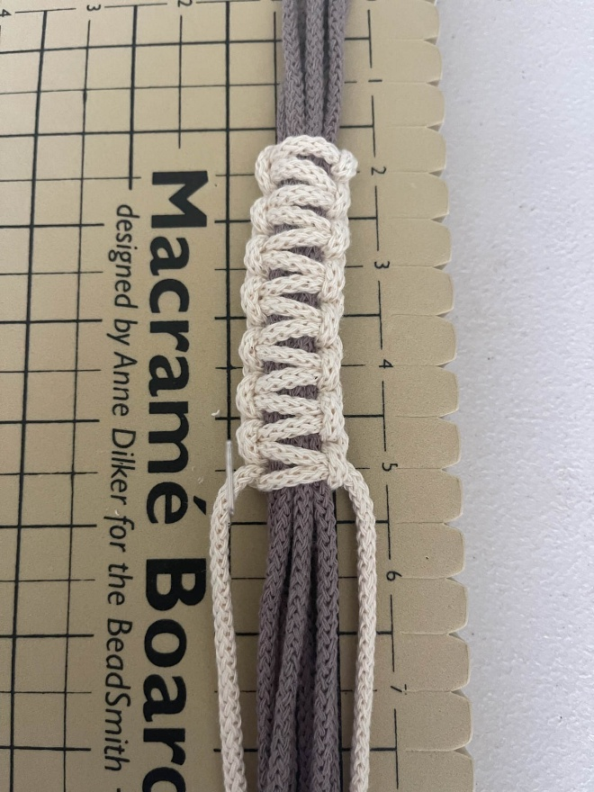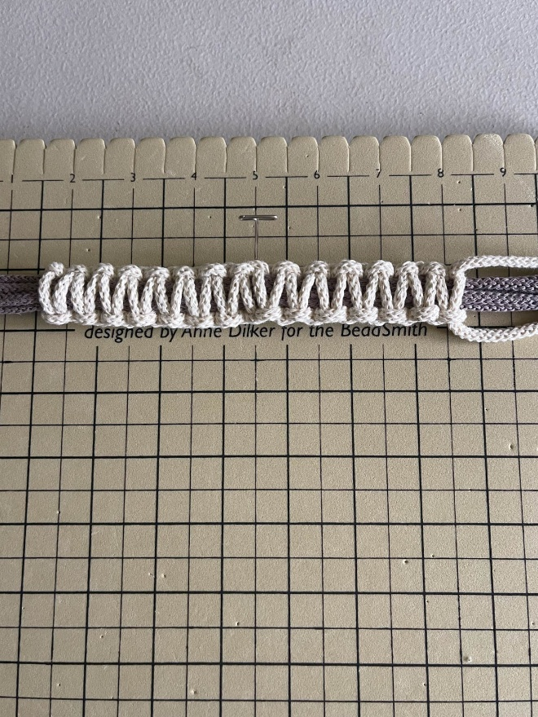

RELATED: 19 Macrame Terms for Beginners You Need to Know
Once you have tied six inches of square knots, fold to make a loop and tie it together with a gathering knot.
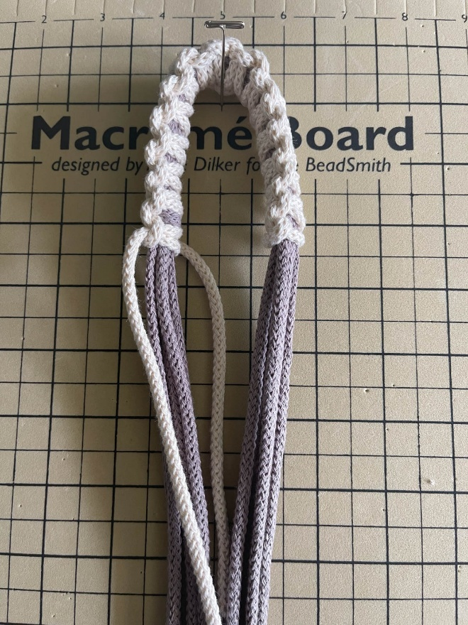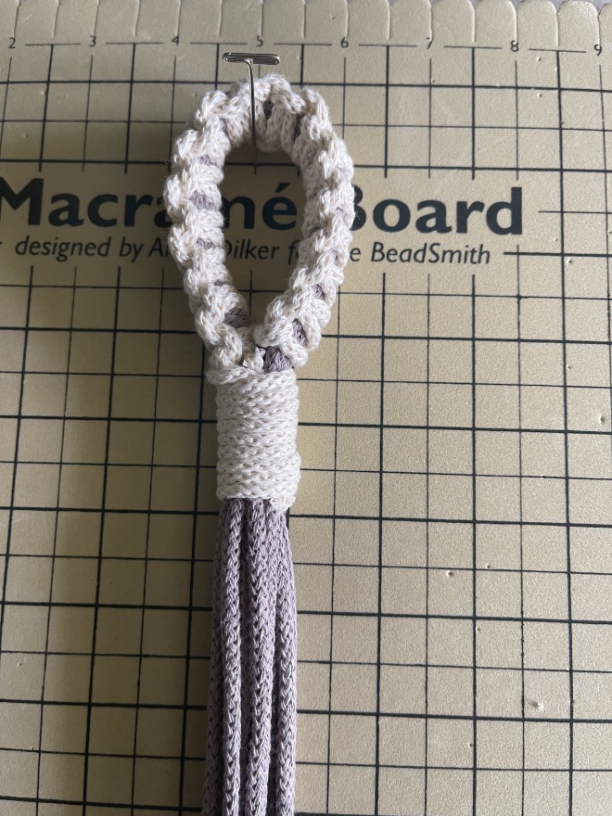
Step 3. Make the plant hanger
Now that your hanging loop is done, it’s time to make the rest of the plant hanger. This one is a very easy plant hanger. I used simple overhand knots to create the arms of the plant hanger DIY no ring.
Place your plant hanger on a hanging hook, My hooks are attached to a clothing rack. Separate your strings into three sets of four.
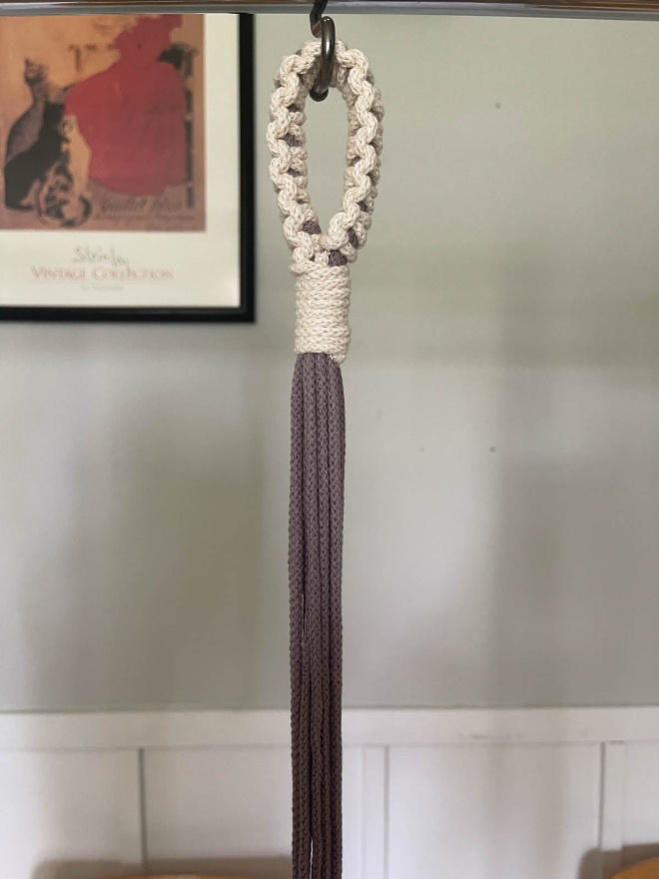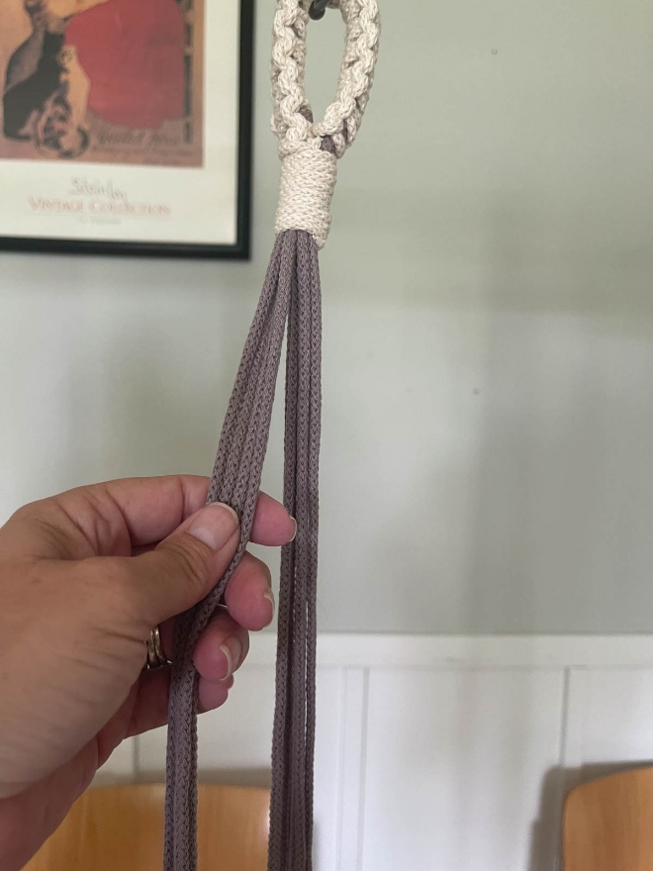
I didn’t measure how far down I was going to tie them. Some people say you should measure your plant pot to determine where to tie your knots, but I’m a go for it kind of person and I usually eyeball it. If you need to measure how far down you are going to tie those first knots, measure down 24 inches.
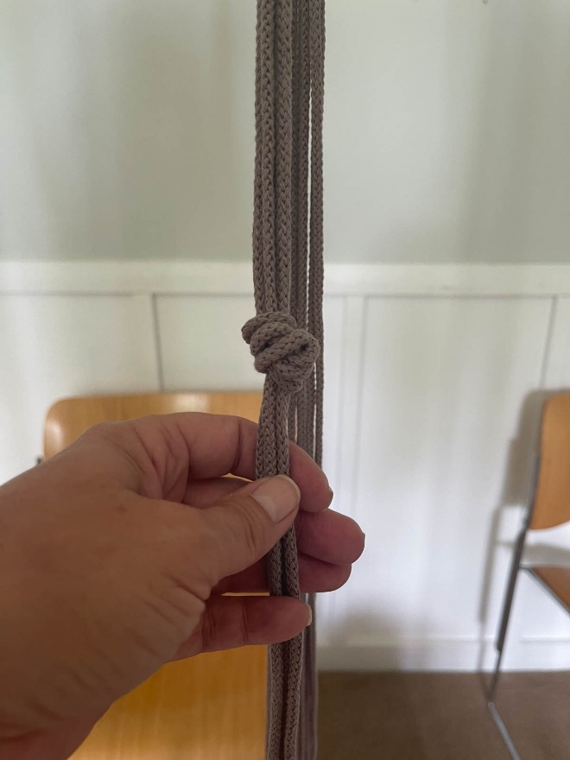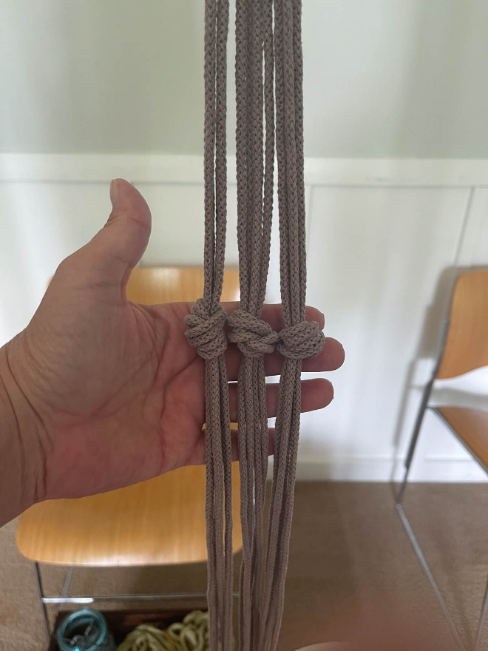
Measure down six inches to make the basket of the no ring macrame plant hanger. Take two strings from one arm and tie them to two strings from the adjacent arm to join them together. Do this with each arm until they are all joined together.
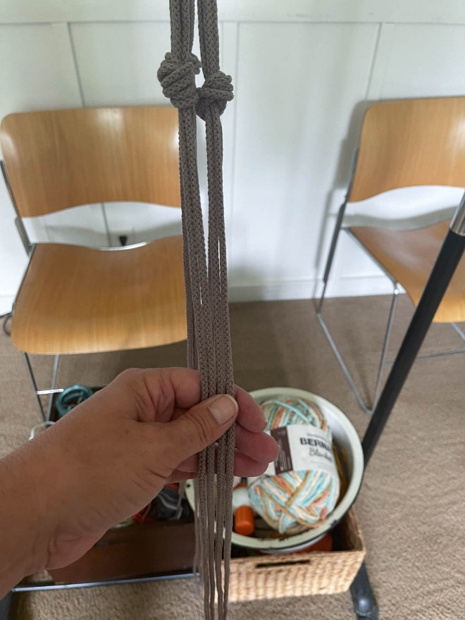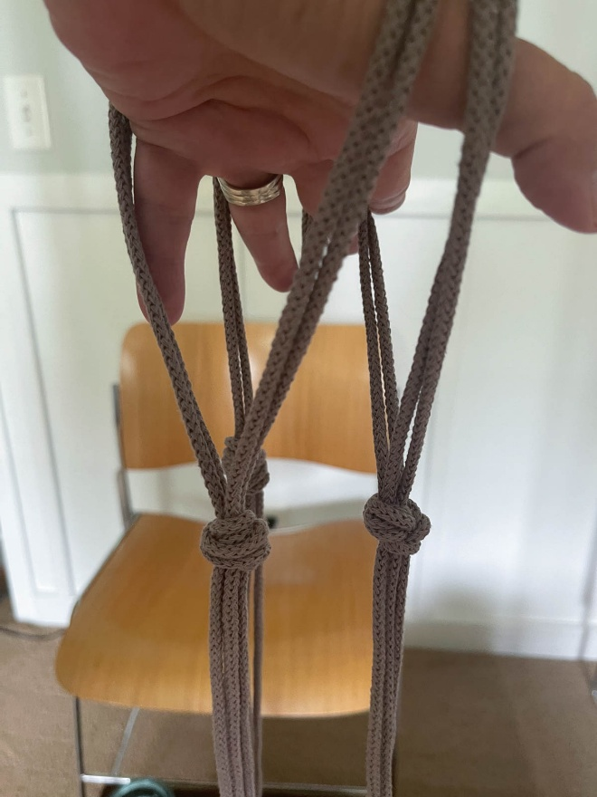
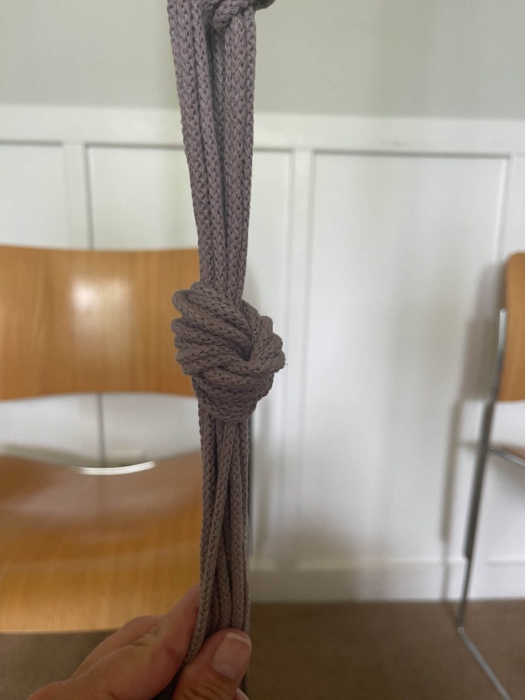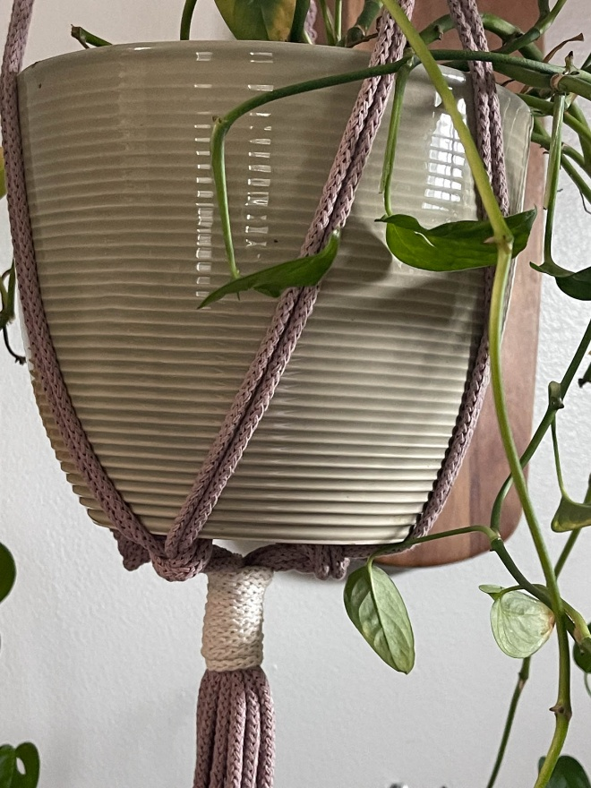
That’s it! Your no ring macrame plant hanger is done. Add your potted plant and hang it up.
Finished using a gathering knot. The pot is bigger in this one and you can see that the knots made for the basket sit under the plant pot.
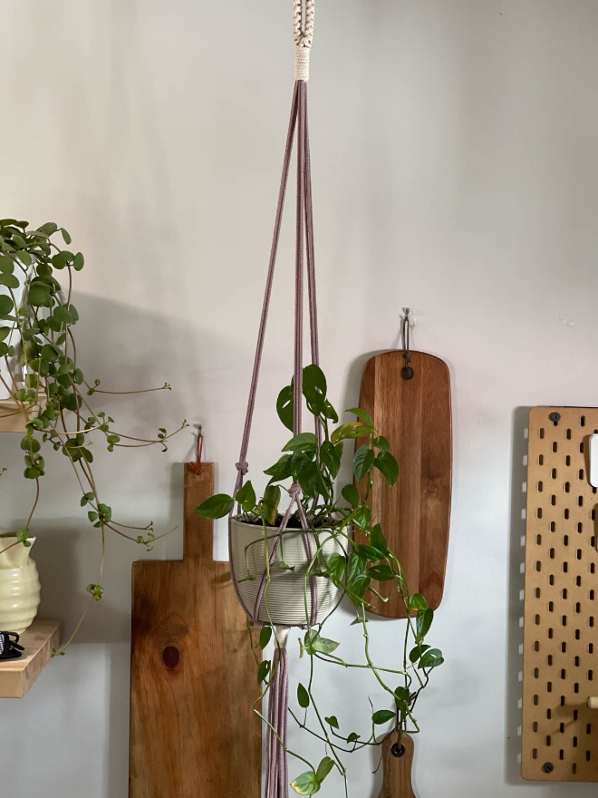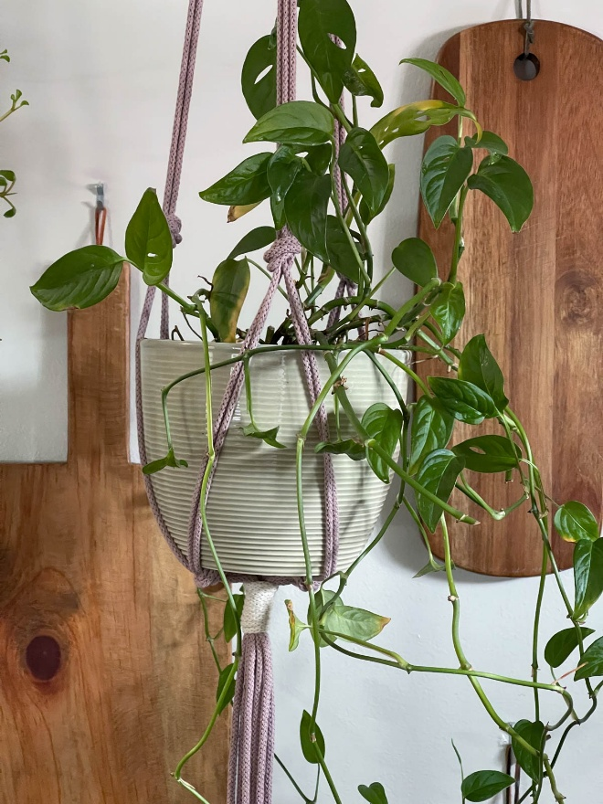
Finished using an overhand knot. This pot is smaller so the knots making the basket fall a fourth of the way up the plant pot.
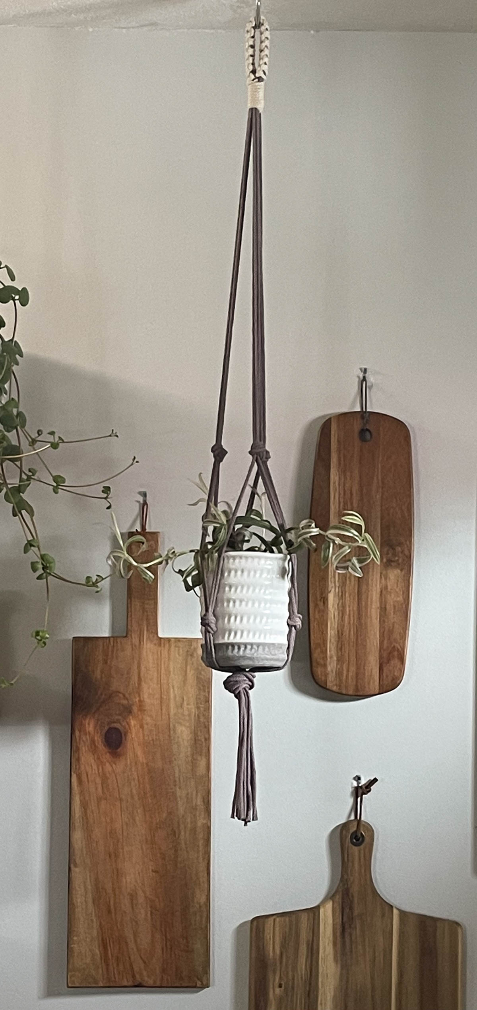
I hope this inspires you to ditch the macrame rings and create your own no ring macrame plant hanger!

